**SPRINT 1 (30/10/2019 – 13/11/2019)**

**Sprint Planning**

Product Backlog:

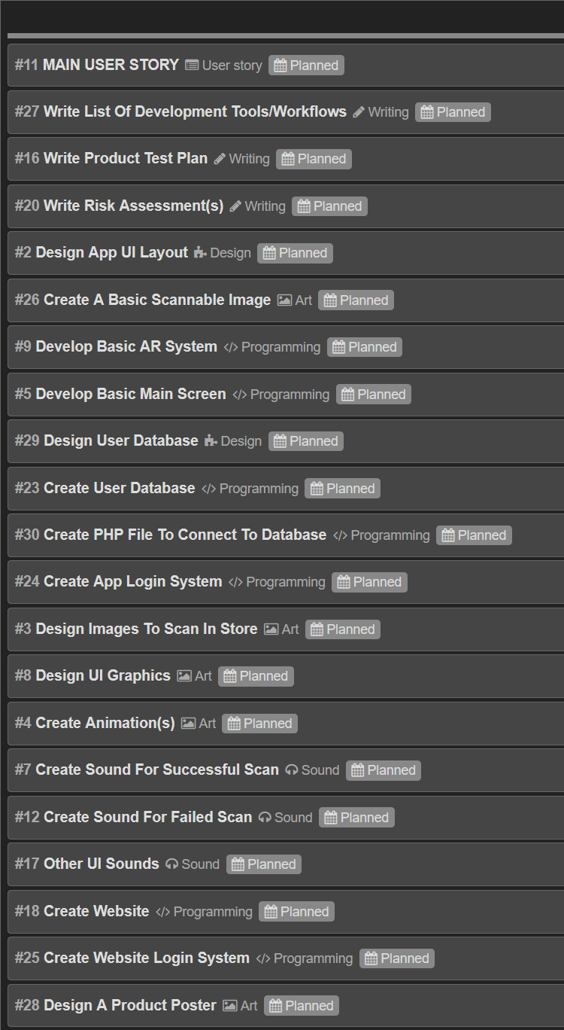

Sprint Backlog:

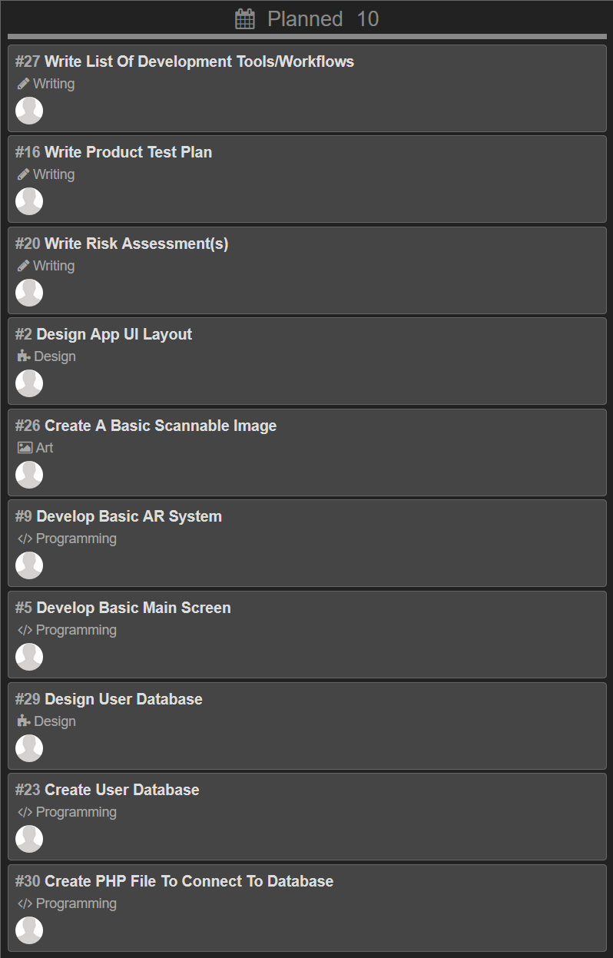

**Meetings/Discussions**

MEETING – Wednesday 6th November (06/11/2019) – In University

MEMBERS ATTENDED:

Abishek, Alex, Ann, John (Michaela absent)

WHAT HAS BEEN DONE SO FAR?

* John created a database to store users and the products that they have scanned using the app. This includes a database design using an Entity-Relationship Diagram and a physical model alongside the database itself, stored in a .sql file.
* Abishek created a test plan

ISSUES:

* Little had been done up to this point due to uncertainty as to how we would implement the final product – e.g. what tools/software we would use, how it would actually work, etc. due to none of us having experience with AR software before.
* There has been a lack of communication so far; plus Michaela’s absence meant we could not discuss the current concerns with her.
* John has raised concerns about using Azure DevOps as the repository, as the flow to download, change and commit files appears more complicated than GitHub, which group members are more familiar with.

MEETING OUTCOMES:

* The repository has been changed from Azure DevOps to GitHub, as the latter provides an easier way to handle changes and commits through its desktop app, which makes it particularly useful for large projects.
* We have agreed on tasks for other members of the group.
* We have determined what tools to use for designing the app itself. It will be created using Unity with the integrated Vuforia Engine.
* We have chosen to limit the current scope of the project to iOS devices only. If the project progresses far enough in the future, we may return to create an Android version of the product.
* In terms of communication, we have created a WhatsApp group which we will use to communicate outside of university times. The main points of this meeting will be posted there to remind members of the current situation and/or discuss any other points.

**Sprint Review**

Tasks at end of Sprint:

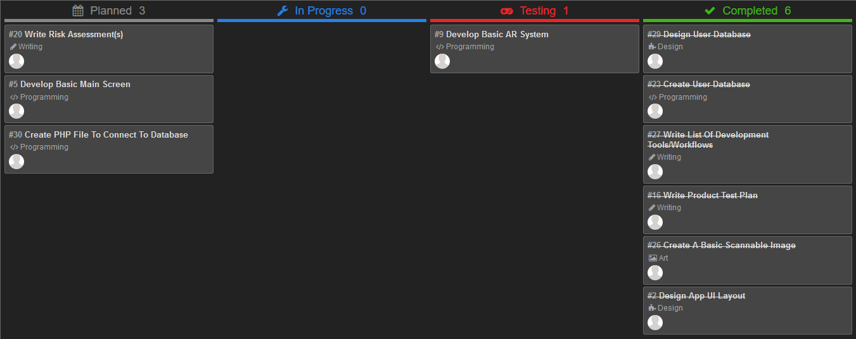

**Sprint Retrospective**